SF ITALIAN HERITAGE

2025 EXPLORER APPLICATION

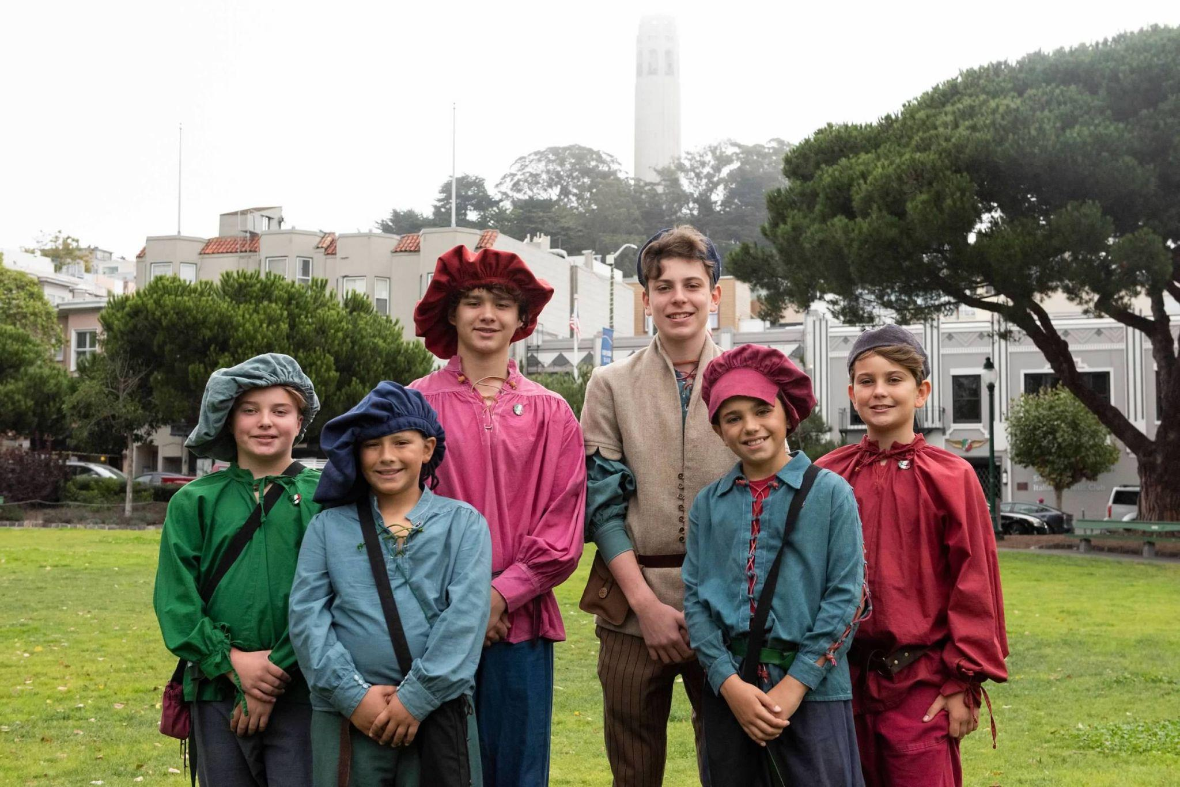

(must be at least 10 years old by October 2025)

**EXPLORER INFORMATION**

**Full Name:___________________________________________________________________ Full Mailing Address:____________________________________________________________ Applicants Phone: _____________________________________________________________ Applicants Email: ______________________________________________________________ School Attending_______________________________________________________________**

**Birthday: _______________________ Age at time of Parade: _________________________**

**PARENT / GUARDIAN INFORMATION:**

**Full Name:___________________________________________________________________ Full Mailing Address:____________________________________________________________ Parent/Guardian Phone:_________________________________________________________ Parent/Guardian Alternate Phone: ________________________________________________ Parent/Guardian Email: _________________________________________________________**

**TELL US ABOUT YOURSELF**

**What does it mean to you, to be part of the Explorers for the SF Italian Heritage?** ____________________________________________________________________________________ ____________________________________________________________________________________ ____________________________________________________________________________________ ____________________________________________________________________________________

**What are some of the traditional Italian festivals, and how are they celebrated?** ____________________________________________________________________________________ ____________________________________________________________________________________ ____________________________________________________________________________________ ____________________________________________________________________________________

**What region is your family from in Italy and list one distinct cultural contribution?** ____________________________________________________________________________________ ____________________________________________________________________________________ ____________________________________________________________________________________ ____________________________________________________________________________________

***What is the significance of La Befana in Italian culture?***

____________________________________________________________________________________ ____________________________________________________________________________________ ____________________________________________________________________________________ ____________________________________________________________________________________

*As ambassadors for our Italian Heritage, participation in civic events as well as the Italian Heritage events listed below*

*Please be sure that you will be able to make the following commitments:*

* *Orientation - TBD*
* *Fundraising Dinner – Friday, September 5, 2025*
* *SF Italian Heritage Giants Game - TBD*
* *Picture Day – Saturday, September 6, 2025*
* *Light Up the TriColore 2024- Saturday, October 4, 2025*
* *Italian Consulate Reception – Friday, October 10, 2025*
* G*rand Ball – Saturday, October 11, 2025*
* *High Mass and Italian Heritage Parade – Sunday, October 12, 2025*

***(dates/times are subject to change)***

***You will receive an email confirmation of receipt of the application.***

Please submit your application to:

[sfihexplorers@gmail.com](mailto:sfihexplorers@gmail.com)

**Applicant Signature: _________________________________________________ Parent Signature: ___________________________________________________ Date: _________________**

**Have questions? Please contact:**

Tracy DeAmicis McMahan, Explorer Director & Marcello Prudente Reilly, Assistant Director [sfihexplorers@gmail.com](mailto:sfihexplorers@gmail.com)