**San Francisco Italian Heritage**

**2025 Queen Isabella Court Application**

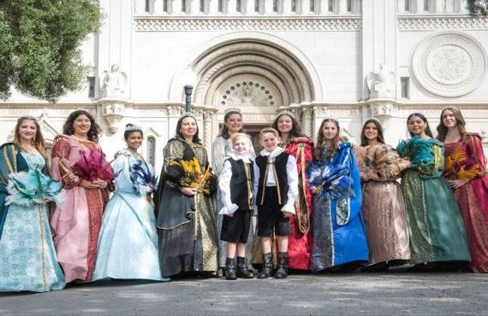

**APPLICANT INFORMATION**

**Please write clearly**

**Must be between the ages of 14-25 as of October 2025**

**APPLICANTS INFORMATION**

**Full Name:___________________________________________________________________ Full Mailing Address:____________________________________________________________ Applicants Phone: _____________________________________________________________**

**Applicants Email: ______________________________________________________________**

**School Attending/Place of Work__________________________________________________**

**Birthday: ________________________ Age at time of Parade: _________________________**

**PARENT/GUARDIAN INFORMATION**

**Full Name: ___________________________________________________________________ Full Mailing Address: ____________________________________________________________ Parent/Guardian Phone:_________________________________________________________**

**Parent/Guardian Alternate Phone: ________________________________________________**

**Parent/Guardian Email: _________________________________________________________**

**Tell us about yourself:**

**How did you hear about the Court of Queen Isabella? If you are a past court member, why do you want to continue the court of Queen Isabella?**

___________________________________________________________________________________________ ___________________________________________________________________________________________ ______________________________________________________________________________________________________________________________________________________________________________________

**Name two famous landmarks in Italy and explain their significance?**

___________________________________________________________________________________________ ___________________________________________________________________________________________ ______________________________________________________________________________________________________________________________________________________________________________________

**What is the tradition of the “Palio” in Siena?** ___________________________________________________________________________________________ ___________________________________________________________________________________________ ______________________________________________________________________________________________________________________________________________________________________________________

**What is Italy’s most popular sport, and who are some of its famous athletes?**

___________________________________________________________________________________________ ___________________________________________________________________________________________ ______________________________________________________________________________________________________________________________________________________________________________________

**What does it mean to you, to be a member of the SF Italian Heritage Court of Queen Isabella?**

___________________________________________________________________________________________ ___________________________________________________________________________________________ ______________________________________________________________________________________________________________________________________________________________________________________

***The Queen and her court reign for one year: October 2025 – October 2026***

***You will receive an email confirmation of receipt of application.***

*As ambassadors for our Italian Heritage, participation in civic events as well as the*

*Italian Heritage events listed below.*

* *Orientation – Sunday March 23. 2025*
* *Interviews - Sunday March 30, 2025*
* *Festa Coloniale Italiana – Saturday & Sunday June 3–4, 2025*
* *SF Giants Italian Heritage Night – TBD*
* *Court Luncheon- Sunday August 3, 2025*
* *Fundraising Dinner – Friday, September 5th, 2025*
* *Picture Day – Saturday, September 6th, 2025*
* *Madonna Del Lume Blessing of the Fleet- Saturday, October 4th, 2025*
* *Madonna Del Lume Mass. Parade & Dinner - Sunday October 5th, 2025*
* [*Light Up the TriColore 2*](https://san-francisco-italian-heritage.myshopify.com/products/light-up-the-tricolore-1)*025 - Saturday October 4, 2025*
* *Italian Consulate Reception – Friday October 10, 2025*
* *Grand Ball – Saturday, October 11th, 2025*
* *High Mass and Italian Heritage Parade – Sunday, October 12th, 2025*

*Dates/times are subject to change*

*Please be sure that you will be able to make the following commitments:*

***Applications will be accepted until March 14, 2025, or when capacity is reached***

*Any questions please contact: courtdirector@gmail.com*

**Applicant Signature: _________________________________________________**

**If under 18 years of age**

**Parent Signature: ___________________________________________________**

**Date: __________**

**Email your application to:**

**Courtdirector@sfitalianheritage.org**